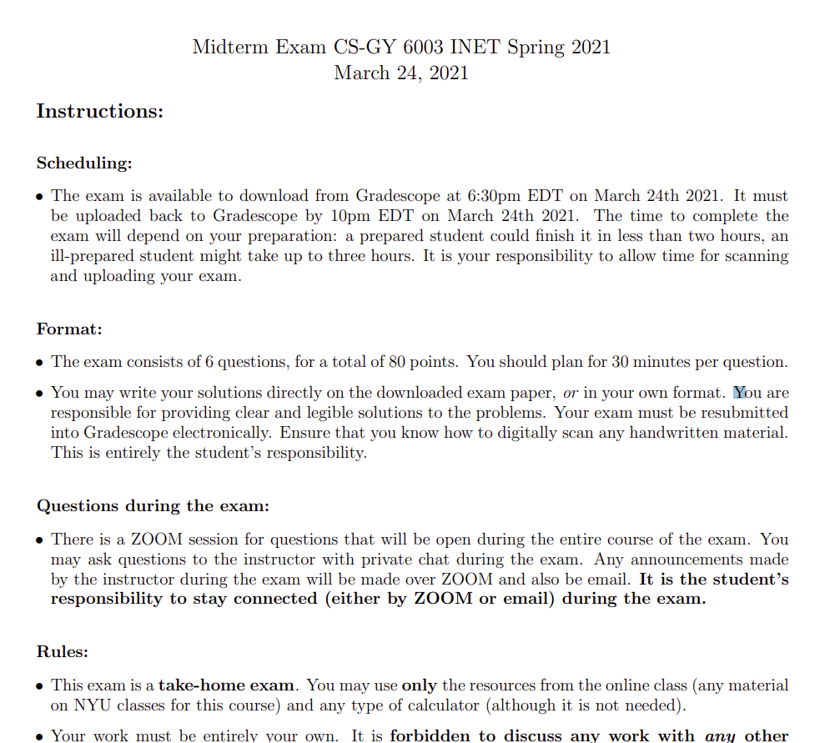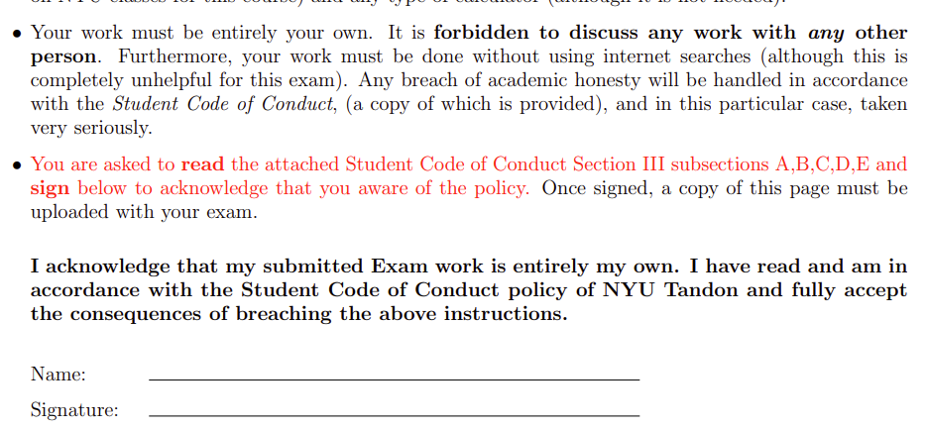



Question 1

(15 points) Show your work

1. Write the following statements in predicate logic using only the predicates C(x) for x is cheating and G(x) for x gets caught, where x is assumed in the domain of students. Using students a, b, c, give an example to show that the two statements below are not equivalent.

C(x): x is cheating

G(x): X gets caught

* If no student gets caught, then not everyone was cheating.

¬∀x(G(x)) → ¬ ∀x (C(x))

* Every student who is cheating gets caught.

¬∀x(C(x) → G(x))

The two are not equivalent because under these conditions:

* Student A and B are cheating
  + Student B gets caught
* Student C is not cheating and does not get caught.

The first statement would always be true because the condition is that no student gets caught, meaning none of the domain of students. B was caught cheating, making this false. If G(X) is false, then C(X) can be true or false and the implication will be true.

However, the second statement is using specifically the domain of students who were cheating. Student A is cheating, but he wasn’t caught, making this statement false.

1. Prove or disprove each of the following statements:

Direct proof:



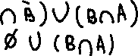

* If A = the set of even integers, and B = { 1/n | n ∈ N}, then A and B have the same cardinality. (here N does not include 0).
* A is the set of infinitely countable numbers
* B is the set of infinitely countable numbers as well
* These two would have the same cardinality if there is a bijection from A to B.
  + There is no bijection from A to B because A includes only even numbers, but B requires the set of natural numbers.
    - Odd numbers for n in B wouldn’t be available such as 1/3 or 1/1
* These two do not share the same cardinality.

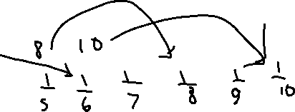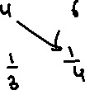

Question 2

(10 points). Show your work!

(a) Let f(n) = √n (log n + 2n) and g(n) = 3n + log n. Prove either f(n) is O(g(n)) or g(n) is O(f(n)).

Only one is true.



$$f\left(n\right)=g\left(n\right)$$

$$\sqrt{n}*\log{n}+2^{n}≤3^{n}+\log{n}$$

$$Because \sqrt{n}\log{n}>\log{n}, exaggerate the right side$$

$$\sqrt{n}*\log{n}+2^{n}≤c*3^{n}+ \sqrt{n}\log{n}$$

$$2^{n}≤1*3^{n}, c=1$$

$$f\left(n\right)≤g(n)$$

$$g\left(n\right)is O\left(f\left(n\right)\right) when c=1$$

* Injective: Every pair must be unique
* Surjective: Every value of B must have a corresponding pair

F(n): (0,0) (1, 2), (2, 4), (3, 6)…(n, 2n)

G(N): (0, 0), (1, 0), (2, 1), (3, 1), (4, 2)…

F◦G : (0,0) (1,0), (2, 2), (3, 2), (4, 4), (5, 4)…

* Not injective because two consecutive pairs will end up with y value because of n/2 rounded down will yield the same pair for every 2 pairs of values.
* Not surjective because odd values are not present in the composite set.
  + F(n) = 2n means only even values will show up.

Question 3

(15 points) Show your work for all parts

1. Evaluate the following sums, or provide a justification that the sum does not exist.

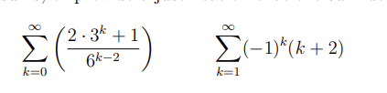

$$\sum_{k=0}^{∞}{\frac{2*3^{k}+1}{6^{k-2}}}$$

$$Must evenly displace the k values$$

$$2\sum_{k=0}^{∞}{\frac{3^{k}}{6^{k}}}*6^{2}+ \sum_{k=0}^{∞}{\frac{1}{6^{k}}*6^{2}}$$

$$72\sum_{k=0}^{∞}{\frac{3^{k}}{6^{k}}}+36\sum_{k=0}^{∞}{\frac{1}{6^{k}}}$$

$$The values of r are≤\left|1\right| which means it does converge, so a sum should exist$$

$$\sum_{k=0}^{∞}{a*r^{k}}=\frac{a}{1-r} geometric series$$

$$72*\frac{1}{1-\frac{3}{6}}+36*\frac{1}{1-\frac{1}{6}}=72*\frac{1}{0.5}+36*\frac{1}{\frac{5}{6}}$$

$$144+43.2=\frac{936}{5}$$

$$\sum_{k=1}^{∞}{{\left(-1\right)}^{k}*\left(k+2\right)}$$

$$\sum_{k=1}^{∞}{{\left(-1\right)}^{k}*\left(k+2\right)}$$

$${\left(-1\right)}^{k} has an absolute value that is≥1$$

$$That means the series has no bound and sums up infinitely. There is no sum.$$

1. (b) You have 3 friends, a, b, c. Over the next 7 days, you invite a subset of your friends to dinner. Each subset is called a “guest list”. No guest list is repeated, and inviting no friends is no possible. You define a relation R on your set of possible guest lists as follows: two guest lists are related if there is exactly one person in common between the two guest lists. Draw the graph for this relation. Determine if this relation is reflexive, transitive, anti-symmetric, and/or symmetric. Justify your answer. Next, show the minimum number of arrows that must be added to the graph of R in order to make it an equivalence relation.

P(A) = {a, b, c, **(a, b), (a, c)**, **(b, c), (a, b, c)**}

The empty set is not included.

* **Not Reflexive**
  + The condition to be related is if exactly one person is shared between two guest lists. Reflexive conditions for (a, b) would have to people sharing the same list.
* **Symmetric**
  + If element A shares a relation with element B, then that means there is one person that can be shared between them
  + This also means that the same person in element B is shared with element A
* **Not Anti-Symmetric**
  + Because the symmetry relation is going both ways. Every set A with set B will also mean every set B is related to A.
* **Transitive**
  + The graph below shows all three relations connected to each other.
    - (a, b) is related to (a, c). (a, c) is related to (b, c). (a, b) is also related to (b, c)
    - This relation applies to all three of the sets below.

Equivalence relations are reflexive, symmetric, and transitive.

Must turn both equivalence relations to have the reflexive

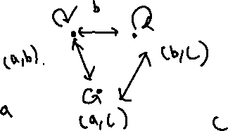

Question 4

(10 points) Show your work

1. A stadium has 35 rows of chairs, each row has exactly 5 seats labeled A, B, C, D, E. In each seat there is either a child or an adult. Prove that there are at least two rows with the same seating arrangement (ex. child, adult, child, child, adult).

There are 5 seats and each seat has two choices.

* Each seat has two choices for child or adult.
* There are 25 = 32 different combinations to choose from to sit either child or adult.
* But there are 35 rows that can hold a different arrangement of child or seats

So by **Pigeonhole principle**, there will be atleast 3 rows that share an arrangement with one or more rows.

1. You have 3 buckets, the first of size 4 gallons, the second of size 10 gallons and the third of size 15 gallons. Show that using these 3 buckets you can measure any number of gallons over 22 gallons. For example, you can make 24 gallons using 6 refills of the first bucket

Induction principle where if it’s over 22 gallons, then any k over 22 gallons can be reduced to a base case of n where n is < k.

|  |  |
| --- | --- |
| 22 | 4*3+10*1+15*0 |
| 23 | 4*2+10*0+15*1 |
| 24 | 4*6 |
| 25 | 4*0+10*1+15*1 |
| 26 | 4*4+10*1+15*0 |

Every over gallon after 26 will just be an additional subtraction of the gallon of 4 to reduce it back to this base case.

Constructive proof:

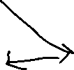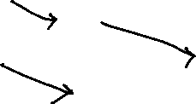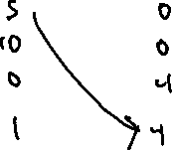

Question 5 (15 points) Show your work

A pile of n bombs need to be safely separated into individual piles of 1 bomb each. A bomb squad has equipment that can separate a pile into two smaller piles. The cost of the separation depends on the size of the two smaller piles. The cost of separating an n-bomb pile into two piles of size k and m is exactly 2mk. (For example, separating a 10-bomb pile into piles of size 3 and 7 costs 2 · 3 · 7 = 42). Prove by induction that regardless of how the bomb squad choses to carry out the separation, that the total cost of placing all bombs into individual piles is n(n − 1).

**Base Case: 1 bomb**

$$B\left(1\right)=1\left(1-1\right)=0 cost$$

There is no cost since there is no need to separate a pile of 1 bomb, passes

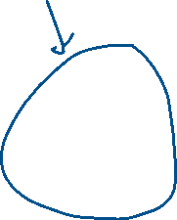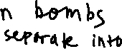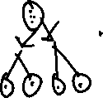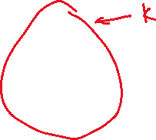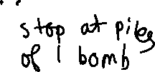

* The set of n bombs is separated recursively into two piles of m and k.
* Each time the pile is separated, it cost 2mk.
  + Each subset in m costs its own 2mk within m
  + Each subset in k costs its own 2mk within k
* The main cost to remove is the cost of n and the pile after below through induction

$$n+1=2m(k+1)+2\left(m+1\right)k$$

$$2mk+2m+2mk+2k$$

$$4mk+2m+2k$$

$$2n+2\left(m+k\right)$$

Question 6

(15 points) Show your work

1. I have $100 and would like to give some to my children C1, C2, and C3. The first child is the oldest and should get at least $20, the second child should get at least $5, and the third child is a baby so she only gets either nothing or $1. How many different ways are there of handing out the money (in dollars), assuming I don’t need to give it all away.

$$C1≥\$20$$

$$C2≥\$5$$

$$C3≤\$1$$

$$C3 has two choices: \$0 or \$1$$

$$C1+C2+C3≤\$100$$

$$Distributing \$100 into 3 children (and 1 leftover in case you choose keep some)$$

Must give C1 $20 and C2 $5 first before deciding the rest of the money. That means $25 are already given away to C1 and C2, leaving behind $75 to decide on.

But because C3 gets 0 or 1, we can split this into two cases.

$$\left({n+k-1 \atop k-1}\right)$$

$$Case 1: C3 gets \$1$$

This leaves $75 but removes C3 from the set of k because we’ve decided he/she will get no money.

K = 3 (C1, C2, leftover bin)

$$\left({75+3-1 \atop 3-1}\right)=\left({77 \atop 2}\right)$$

$$Case 2: C3 gets \$0$$

One more dollar is given away, leaving $74 to distribute, but removes C3 from the set because we decided he/she will get a dollar and no more.

K = 3 (C1, C2, leftover bin)

$$\left({74+3-1 \atop 3-1}\right)=\left({76 \atop 2}\right)$$

$$\left({77 \atop 2}\right)+\left({76 \atop 2}\right)=All possible ways to give the 3 children money$$

Where child 1 gets atleast $25, child 2 gets atleast $5, and child 3 gets $0 or $1, and if you choose to keep some leftover cash for yourself.

1. A password is made by selecting letters from {w, x, y, z}. How many ways can you make a password of length 5 if it must have no x’s or exactly three y’s ? (this is english inclusive or)

Separate by cases then use inclusion-exclusion principle:

$$Case 1: No x's$$

Password is length 5. 5 choices for anything but X

5 times, each length is allowed to have 3 choices.

$$5^{3} arrangements without x$$

$$Case 2: Exactly 3 y's$$

There are 3 y’s already chosen to be in the password. The arrangement of where these y’s are must be determined.

$$\left({5 \atop 3}\right) determine where the 3 y^{'}s will be placed at in the password of length 5$$

The other 2 places can be anything.

$$5^{2}$$

$$5^{2}*\left({5 \atop 3}\right)=Total arrangements where there^{'}s 3 y^{'}s placed anywhere$$

Must exclude the intersection where there are 3 y’s and any number of x’s

$$Case 1: 3 y^{'}s and 1 x$$

$$\left({5 \atop 3}\right) choices for the 3 y's$$

$$1 x can go anywhere while another is free to be anything. Assume we^{'}re placing the y^{'}s first$$

$$\left({2 \atop 1}\right) places to choose x after the y's$$

$$\left({1 \atop 1}\right)5^{3} choices for the last letter to be anywhere (can^{'}t be x)$$

$$Multiplication rule: \left({5 \atop 3}\right)\left({2 \atop 1}\right) \left({1 \atop 1}\right)5^{3}$$

$$Case 2: 3 y^{'}s and 2 x's$$

We know what all the letters in this arrangement is, so we only need to determine the order. Because the amount being distributed is already set, this is a multinomial.

$$\left({5 \atop 3 2}\right)=\frac{5!}{3!2!} arrangements of 3 y^{'}s and 2 x's$$

Combining everything into the inclusion-exclusion principle:

$$5^{3}+5^{2}*\left({5 \atop 3}\right)-\frac{5!}{3!2!}-\left({5 \atop 3}\right)\left({2 \atop 1}\right) \left({1 \atop 1}\right)5^{3}$$

1. There are 10 students waiting to order food from 4 different restaurants. Each student picks a restaurant and must line up in front of the restaurant. The restaurants are each different! How many different ways are there for the students to line up in front of the restaurants? Consider both the number of people in each line, and their order. A line may be empty

* Restaurants are distinct. Distinct bins
* Students are identical. Indistinct objects.
* Indistinct students are being distributed to distinct restaurants.
  + Empty restaurants allowed.

$$\left({n+k-1 \atop k-1}\right): Ways to distribute n identical objects to k distinct bins where bins can be empty$$

$$n=10 students, k=4 restaurants$$

$$\left({10+4-1 \atop 4-1}\right)=\left({13 \atop 3}\right)=286 possible arrangements$$